GTBank Database System Report

1. Introduction
This project is a relational database system designed for a banking environment. The goal is to store, manage, and analyze customer and financial data efficiently.
The system includes key banking operations such as:
- Customer management
- Account tracking
- Transaction recording
- Loan management
- Branch operations
The database was implemented using SQL with proper relationships to ensure data integrity.

2. Database Schema (Diagram)
- Draw 5 tables:
  - Customers
  - Accounts
  - Transactions
  - Loans
  - Branches
Show relationships:
- Customers → Accounts (1-to-many)
- Accounts → Transactions (1-to-many)
- Customers → Loans (1-to-many)
- Branches → Accounts (1-to-many)

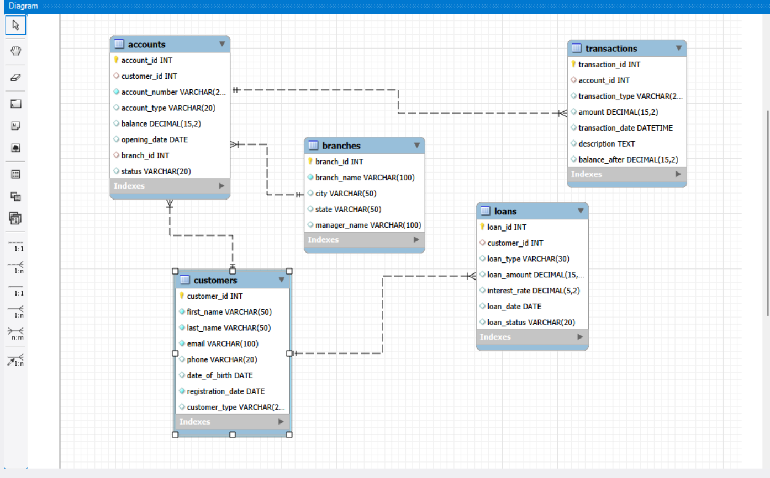

3. Query Results
Example:
🔹 Top Customers by Balance
SELECT c.customer_id, c.first_name, c.last_name, SUM(a.balance) AS total_balance
FROM customers c
JOIN accounts a ON c.customer_id = a.customer_id
GROUP BY c.customer_id
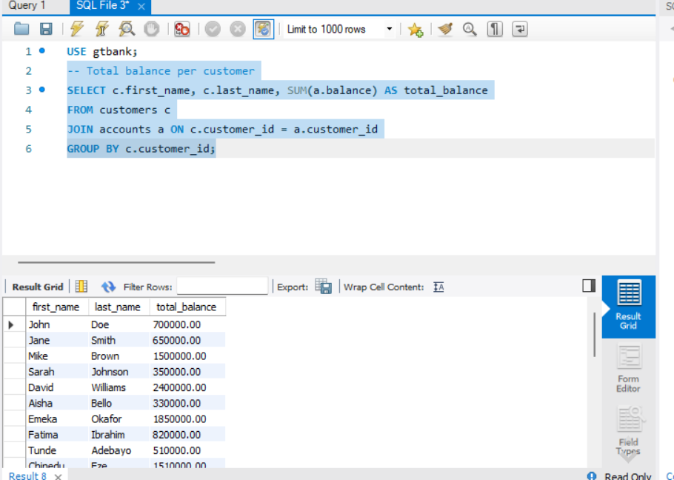

🔹 Large Transactions (Fraud Check)
SELECT c.first_name, c.last_name, t.amount, t.transaction_date, t.transaction_type
FROM customers c
JOIN accounts a ON c.customer_id = a.customer_id
JOIN transactions t ON a.account_id = t.account_id
WHERE t.amount > 500000;
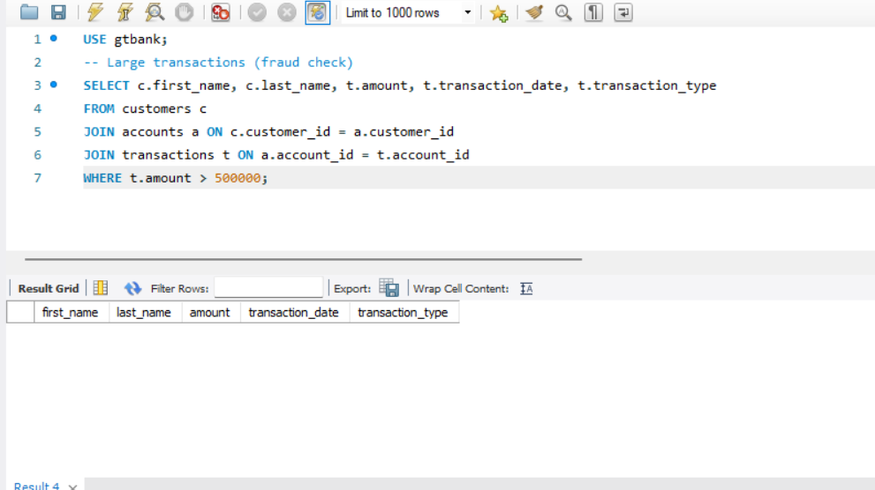

🔹 Branch Performance
SELECT b.branch_name, SUM(a.balance) AS total_balance
FROM branches b
JOIN accounts a ON b.branch_id = a.branch_id
GROUP BY b.branch_id;
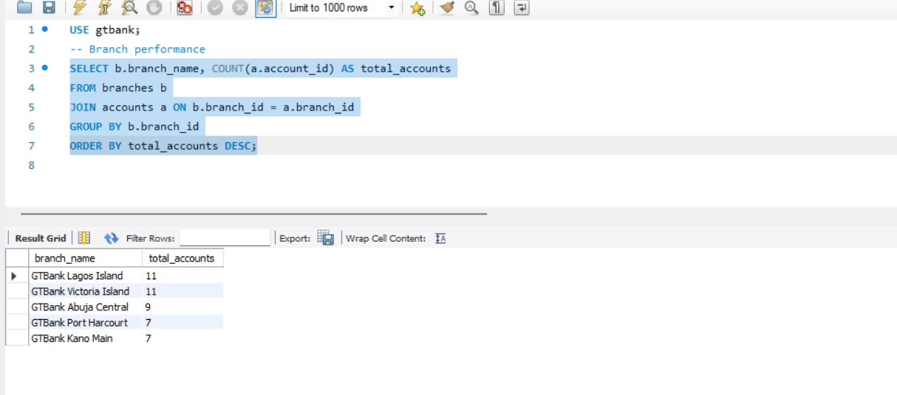

🔹 Most Active Accounts
SELECT account_id, COUNT(*) AS total_transactions
FROM transactions
GROUP BY account_id
ORDER BY total_transactions DESC
LIMIT 1;
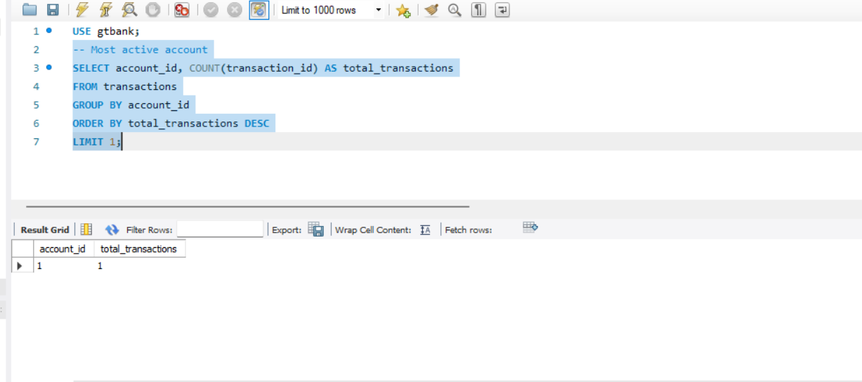

4. Key Findings & Insights
- Most customers maintain multiple accounts, showing banking usage.
- A small number of customers hold very high balances, indicating high-value clients.
- Transactions are frequent, with some accounts showing very high activity levels.
- Certain transactions exceed ₦500,000 daily, which may indicate potential fraud or high-value transfers.
- Some accounts have low balances, which may indicate inactive or low-income customers.

5. Business Recommendations
✔ Recommendation 1:
The bank should monitor large transactions above ₦500,000 to detect and prevent fraud.
✔ Recommendation 2:
High-value customers should be offered premium services ;to retain them.
✔ Recommendation 3:
Inactive or low-balance accounts should be targeted with marketing campaigns to increase engagement.
✔ Recommendation 4 :
Branches with high performance should be used as a benchmark for improving weaker branches.

6. Conclusion
The database system successfully models a real-world banking system.
It allows efficient data storage, relationship management, and analysis.
The queries provide meaningful insights that can help improve:
- Customer service
- Fraud detection
- Business decision-making

